1. **BANK LOAN REPORT | SUMMARY**

**KPI’s :**

1. **Total Loan Applications**

select count(id) as Total_Loan_Applications from bank_loan_data



**MTD Loan Applications**

select count(id) as MTD_Total_Loan_Applications from bank_loan_data

where MONTH(issue_date) = 12 and YEAR(issue_date)



**PMTD Loan Applications**

select count(id) as PMTD_Total_Loan_Applications from bank_loan_data

where MONTH(issue_date) = 11 and YEAR(issue_date) = 2021



1. **Total Funded Amount**

select SUM(loan_amount) as Total_Funded_Amount from bank_loan_data



**MTD** **Total Funded Amount**

select SUM(loan_amount) as MTD_Total_Funded_Amount from bank_loan_data

where MONTH(issue_date) = 12 and YEAR(issue_date) = 2021



**PMTD** **Total Funded Amount**

select SUM(loan_amount) as PMTD_Total_Funded_Amount from bank_loan_data

where MONTH(issue_date) = 11 and YEAR(issue_date) = 2021



1. **Total Amount Received**

SELECT SUM(total_payment) AS Total_Amount_Recieved FROM bank_loan_data



**MTD Total Amount Received**

select sum(total_payment) as MTD_total_Amount_Recieved from bank_loan_data

where month(issue_date) = 12 and year(issue_date) = 2021



**PMTD Total Amount Received**

select sum(total_payment) as PMTD_Total_Amount_Recieved from bank_loan_data

where month(issue_date) = 11 and year(issue_date) = 2021



1. **Average Interest Rate**

select round(AVG(int_rate),4) * 100 as Average_interest_Rate from bank_loan_data



**MTD Average Interest Rate**

select round(avg(int_rate),4) * 100 as MTD_Average_Interest_Rate from bank_loan_data

where month(issue_date) = 12 and year(issue_date) = 2021



**PMTD Average Interest Rate**

select round(avg(int_rate), 4) *100 as PMTD_Average_interest_rate from bank_loan_data

where MONTH(issue_date) = 11 and year(issue_date) = 2021



1. **Average Debt-to-Income Ratio**

select round(avg(dti), 4) *100 as Avg_DTI from bank_loan_data



**MTD Average Debt-to-Income Ratio**

select round(avg(dti), 4) *100 as MTD_Avg_DTI from bank_loan_data

where month(issue_date) = 12 and year(issue_date) = 2021



**PMTD Average Debt-to-Income Ratio**

select round(avg(dti), 4) *100 as PMTD_Avg_DTI from bank_loan_data

where month(issue_date) = 11 and year(issue_date) = 2021



1. **Good Loan Issued**

**Good Loan Percentage**

select (count(case when loan_status = 'Fully Paid' or loan_status = 'Current' then id end)*100.0)/count(id) as Good_loan_percentage

from bank_loan_data



**Good Loan Applications**

select count(id) as Good_Loan_Applications from bank_loan_data

where loan_status = 'Fully Paid' or loan_status = 'Current'



**Good Loan Funded Amount**

select sum(loan_amount) as Good_Loan_Funded_Amount from bank_loan_data

where loan_status = 'Fully Paid' or loan_status = 'Current'



**Good Loan Recieved Amount**

select sum(total_payment) as Good_Loan_Recieved_Amount from bank_loan_data

where loan_status = 'Fully Paid' or loan_status = 'Current'



1. **Bad Loan Issued**

**Bad Loan Percentage**

select (count(case when loan_status = 'Charged Off' then id end)*100.0)/count(id) as Bad_loan_percentage

from bank_loan_data



**Bad Loan Applications**

select count(id) as Bad_Loan_Applications from bank_loan_data

where loan_status = 'Charged Off'



**Bad Loan Funded Amount**

select sum(loan_amount) as Bad_Loan_Funded_Amount from bank_loan_data

where loan_status = 'Charged Off'



**Bad Loan Recieved Amount**

select sum(total_payment) as Bad_Loan_Recieved_Amount from bank_loan_data

where loan_status = 'Charged Off'



1. **LOAN STATUS GRID VIEW**

select loan_status,

count(id) as Total_loan_applications,

sum(total_payment) as Total_Recieved_Amount,

sum(loan_amount) as Total_Funded_Amount,

avg(int_rate * 100) as Interest_rate,

avg(dti * 100) as DTI

from bank_loan_data

group by loan_status

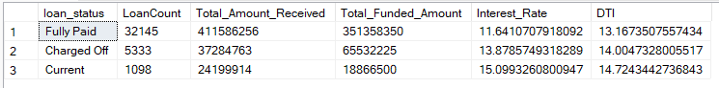

**MTD Amt_funded_vs_amt_recieved**

select loan_status,

sum(total_payment) as MTD_Total_Recieved_Amount,

sum(loan_amount) as MTD_Total_Funded_Amount

from bank_loan_data

where MONTH(issue_date) = 12 and year(issue_date) = 2021

group by loan_status

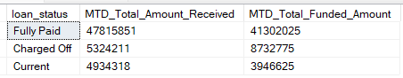

1. **BANK LOAN REPORT | OVERVIEW**
2. **Monthly Trends by Issue Date**

select MONTH(issue_date) as Month_Number,

DATENAME(MONTH, issue_date) as Month_Name,

count(id) as Total_Loan_Applications,

sum(loan_amount) as Total_Funded_Amount,

sum(total_payment) as Total_Recieved_Amount

from bank_loan_data

group by MONTH(issue_date), DATENAME(MONTH, issue_date)

order by MONTH(issue_date)

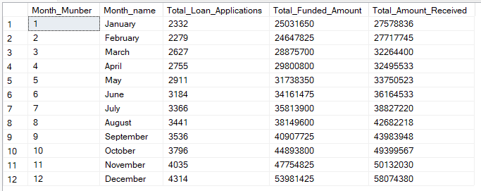

1. **Regional Analysis by State**

select address_state as State,

count(id) as Total_Loan_Applications,

SUM(loan_amount) as Total_Funded_Amount,

sum(total_payment) as Total_Recieved_Amount

from bank_loan_data

group by address_state

order by Total_Funded_Amount desc

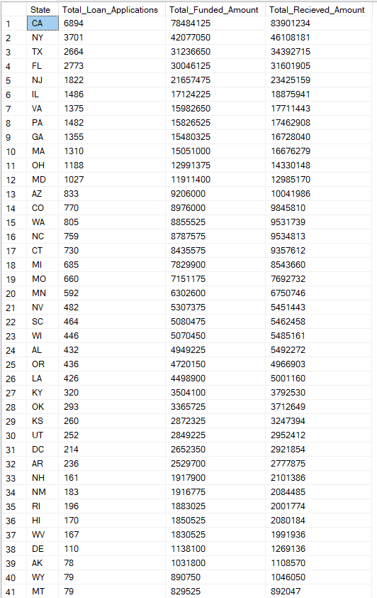

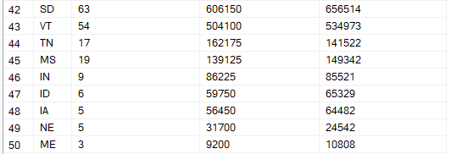

1. **Loan Term Analysis**

select term as Loan_Term,

count(id) as Total_Loan_Applications,

SUM(loan_amount) as Total_Funded_Amount,

sum(total_payment) as Total_Recieved_Amount

from bank_loan_data

group by term

order by term

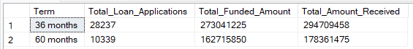

1. **Employee Length Analysis**

select emp_length as Employee_Length,

count(id) as Total_Loan_Applications,

SUM(loan_amount) as Total_Funded_Amount,

sum(total_payment) as Total_Recieved_Amount

from bank_loan_data

group by emp_length

order by emp_length

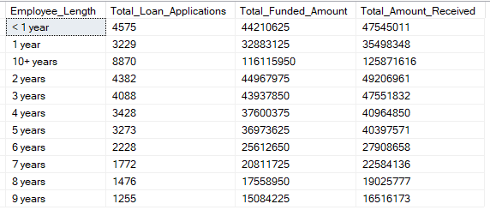

1. **Loan Purpose Breakdown**

select purpose as Purpose,

count(id) as Total_Loan_Applications,

SUM(loan_amount) as Total_Funded_Amount,

sum(total_payment) as Total_Recieved_Amount

from bank_loan_data

group by purpose

order by Total_Loan_Applications desc

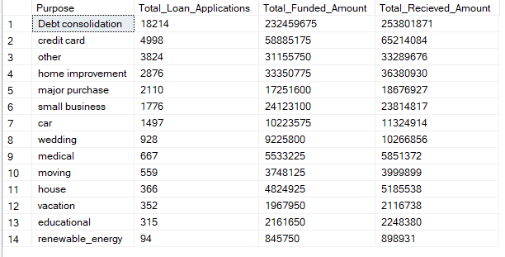

1. **Home Ownership Analysis**

select home_ownership as Home_Ownership,

count(id) as Total_Loan_Applications,

SUM(loan_amount) as Total_Funded_Amount,

sum(total_payment) as Total_Recieved_Amount

from bank_loan_data

group by home_ownership

order by Total_Recieved_Amount desc

